CAS PY 106

Prelecture Note 13

1. Example 1: reducing a circuit to one resistor
2. General rules of thumb when analyzing circuits in which the resistors are connected in series-parallel combinations
3. Goal is to contract circuit from n resistors shown, first to an equivalent set of n-1, then to equivalent set of n-2, until it goes to one equivalent resistor
4. After we determined single equivalent resistor, we can find current in circuit
5. We gradually expand circuit back to n-2 resistors, n-1 resistors, and n resistors
6. At each step, we determine voltage across each resistor, and current through it
7. Example
8. 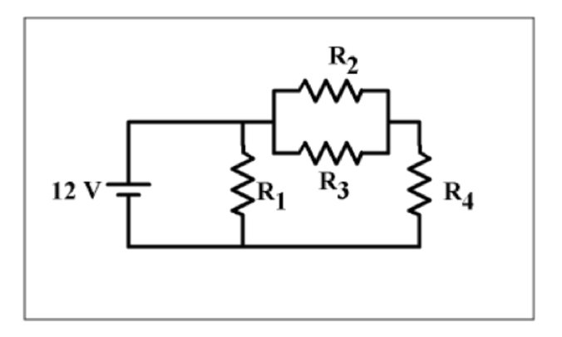
9. For this circuit, R1 = 6 Ohms, R2 = 36 Ohms, R3 = 12 Ohms, R4 = 3 Ohms
10. Step 1
11. First contract the circuit from four resistors to three resistors
12. Identify two resistors that are either in series with one another, or two that are in parallel with one another, replacing the pair by single equivalent resistor
13. Start by thinking R2 and R3 are in parallel with one another
14. Equivalent resistance of resistor 2 and 3

R2 = 36, R3 = 12

1/ (1/36 + 1/12) = 9 Ohms

1. New circuit picture combining R2 and R3
2. 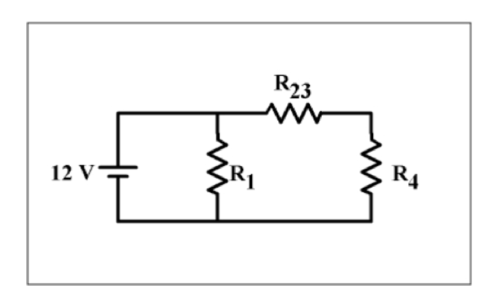
3. Step 2
4. Next contract the circuit from three resistors to two resistors
5. Start by thinking R23 and R4 are in series with one another
6. Equivalent resistance of R23 and R4

R23 = 9, R4 = 3

9 + 3 = 12 Ohms

1. New circuit picture combing R23 and R4
2. 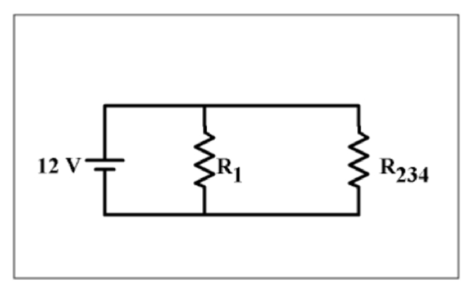
3. Step 3
4. Next contract the circuit from two resistors to one resistor
5. Start by thinking R1 and R234 are in parallel with one another
6. Equivalent resistance of R1 and R234

R1 = 6, R234 = 12

1/ (1/6 + 1/12) = 4

1. New circuit picture above combining R1 and R234
2. 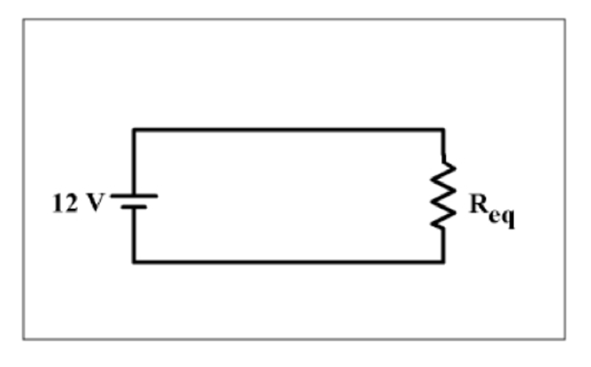
3. Calculate Current
4. I = V/R = 12 / 4 = 3 amps
5. 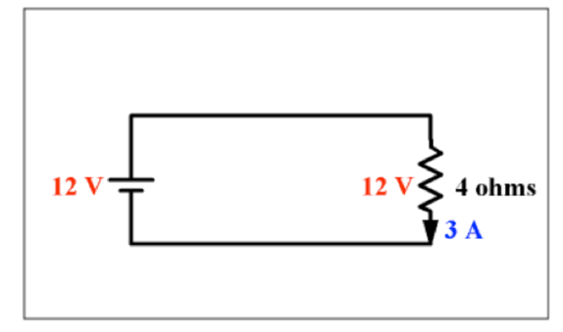
6. Expanding back to two resistors
7. Knowing the potential difference across single equivalent resistor and current, we can find potential difference (V) across and current through two resistors
8. 
9. Potential difference through R1

V = 12 V

1. Potential difference through R234

V = 12 V

1. Current through R1

V = I \* R1

I = 12 / 6 = 2 amps

1. Current through R234

V = I \* R234

I = 12 / 12 = 1 amp

1. The current adds up to 3 amps, which is equal to the current of the circuit
2. Going to Three resistors
3. 
4. Current through R23 and R4 = 1 amp (from above)
5. Potential difference through R23

V = I \* R23

= 1 \* 9 = 9 V

1. Potential difference through R 4

V = I \* R4

= 1 \* 3 = 3 V

1. Potential difference adds up to 12V, equal to the potential difference of the battery
2. Going to Four resistors
3. 
4. Potential difference in R2 and R3 are both 9 V
5. Current through R2

V = I \* R

I = 9 / 36 = ¼

1. Current through R3

V = I \* R

I = 9 / 12 = ¾

1. Current adds up to 1 amp, equal to the current of the circuit